ASSESSMENT COVER SHEET
Unit Name and Code: | FIT 5131
Campus: | Caufild
Assignment Title: | Assignment 1
Name of Lecturer: | Andy Cheng
Name of Tutor: | Andy Cheng
Tutorial Day and Time: | Friday 2-4pm

Phone Number:

Email Address: | Gphei2@student.monash.edu
Has any part of this assignment been previously submitted as part of another unit/course? Yes No
Due Date: | 17 April 2014 | Date Submitted: | 17 Apr. 14
All work must be submitted by the due date. If an extension of work is granted this must be specified with the signature of the lecturer/tutor.
Extension granted until (date)___________________ Signature of lecturer/tutor __________________________
Please note that it is your responsibility to retain copies of your assessments.
Intentional plagiarism or collusion amounts to cheating under Monash University Statute 4.1 – Student Discipline.

Plagiarism: Plagiarism means to take and use another person’s ideas and or manner of expressing them and to pass these off as one’s own by failing to give appropriate acknowledgement, including the use of material from any source, staff, students or the internet, published and unpublished works.

Collusion: Collusion means unauthorised collaboration on assessable written, oral or practical work with another person.Where there are reasonable grounds for believing that intentional plagiarism or collusion has occurred, this will be reported to the Associate Dean (Education) or nominee, who may disallow the work concerned by prohibiting assessment or refer the matter to the Faculty Discipline Panel for a hearing.
Student Statement:
- I have read the university’s Student Academic Integrity Policy and Procedures.
- I understand the consequences of engaging in plagiarism and collusion as described in University Statute 4.1 – Student Discipline, Part 2 Misconduct http://adm.monash.edu/legal/legislation/statutes/statute4-1-student-discipline.pdf.
- I have taken proper care to safeguard this work and made all reasonable efforts to ensure it could not be copied.
- No part of this assignment has been previously submitted as part of another unit/course.
- I acknowledge and agree that the assessor of this assignment may for the purposes of assessment, reproduce the assignment and:
- provide to another member of faculty and any external marker; and/or
- submit it to a text matching software; and/or
- submit it to a text matching software which may then retain a copy of the assignment on its database for the purpose of future plagiarism checking.
- I certify that I have not plagiarised the work of others or participated in unauthorised collaboration when preparing this assignment.
Signature ..................................................... Date…17 Apr. 14…………………………
* delete (iii) if not applicable
Student ID number | 259 127 04
Given Name | Georg Philipp Erasmus
Family name | Heise
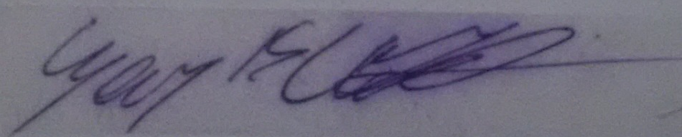
The information on this form is collected for the primary purpose of assessing your assignment. Other purposes of collection include recording your plagiarism and collusion declaration, attending to course and administrative matters and statistical analyses. If you choose not to complete all the questions on this form it may not be possible for Monash University to assess your assignment. You have a right to access personal information that Monash University holds about you, subject to any exceptions in relevant legislation. If you wish to seek access to your personal information or inquire about the handling of your personal information, please contact the University Privacy Officer: privacyofficer@adm.monash.edu.au

